Clustering using Simple K means with iris dataset at 80%  
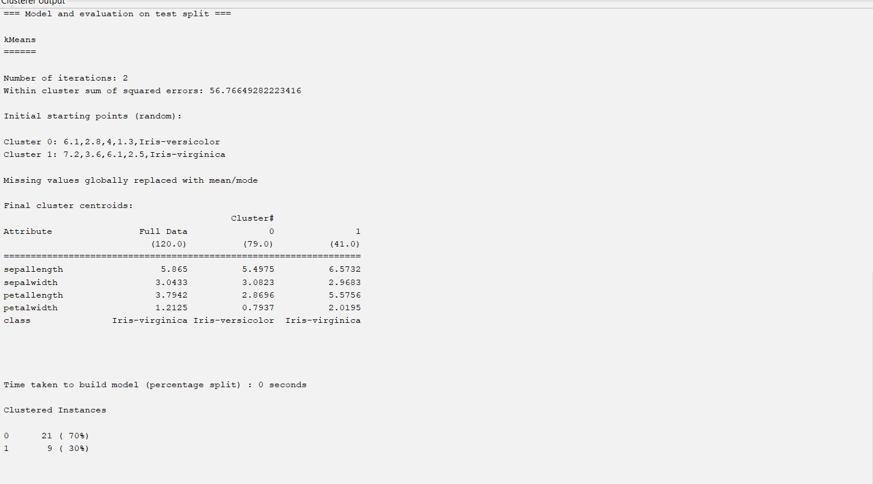

**TP Rate:** The proportion of correctly classified positive instances out of all actual positive instances.

**FP Rate**: The proportion of incorrectly classified negative instances out of all actual negative instances.

**Precision**: The proportion of correctly classified positive instances out of all instances classified as positive.

**Recall**: The proportion of correctly classified positive instances out of all actual positive instances (also known as True Positive Rate).

**F-measure**: The harmonic mean of precision and recall, providing a balance between the two metrics.

**MCC (Matthews Correlation Coefficient)**: A measure of the quality of binary classifications, considering true and false positives and negatives.

**ROC Area**: The area under the Receiver Operating Characteristic curve, representing the model's ability to distinguish between positive and negative classes.

**PRC Area**: The area under the Precision-Recall curve, highlighting the trade-off between precision and recall for different thresholds

1. **Attributes (Features)**: The dataset contains four attributes (features) for each instance:
   * Sepal length (in cm)
   * Sepal width (in cm)
   * Petal length (in cm)
   * Petal width (in cm)
2. **Classes**: The dataset is divided into three classes, each corresponding to a different species of iris flower:
   * Iris-setosa
   * Iris-versicolor
   * Iris-virginica
3. **Instances**: The dataset contains 150 instances (examples), with 50 instances for each of the three species.

**Using the Iris Dataset in Weka**

1. **Loading the Dataset**:
   * In Weka's Explorer interface, you can load the Iris dataset by clicking on the "Open file" button and selecting the iris.arff file, which is available in Weka's sample datasets.
2. **Exploring the Dataset**:
   * You can view the dataset's attributes, inspect its instances, and use Weka's various tools to analyze and visualize the data.
3. **Applying Algorithms**:
   * You can use the Iris dataset to train and test various machine learning algorithms, such as decision trees, k-nearest neighbors, and support vector machines, to classify the iris species

Factors to evaluate Mean , median , standard deviation of data maximum , minimum

Normal-ECG

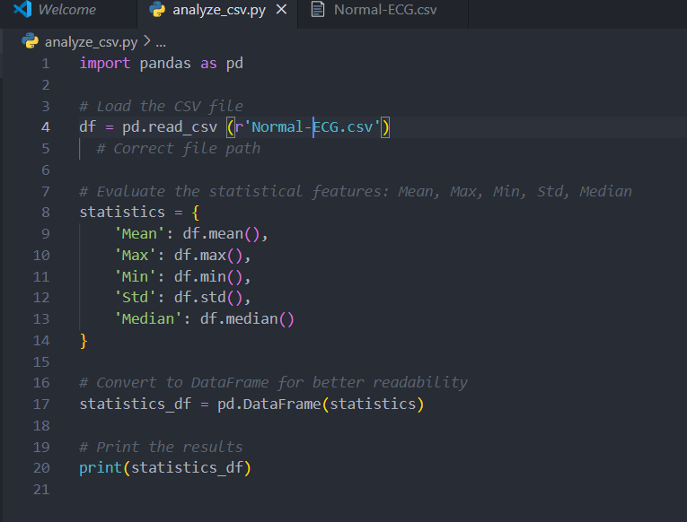

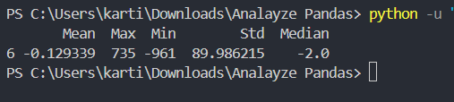

Dia-ECG

